Practical 2: Image Enhancement in the Spatial Domain

Bibek Manandhar

20070282

BE-CMP

EEC

30/01/2024

**Summary:**

The basic image handling using Java and the Eclipse IDE is the main topic of this practical. The code that is provided shows how to read, store, and display photos. Techniques for processing grayscale images are covered, with an emphasis on memory efficiency.

Keywords— Image Enhancement, Log Transform, Histogram Equalization, Correlation, Laplacian, Sobel mask.

1. PROBLEM DESCRIPTION

This practical aims to implement and analyse several image enhancement techniques in the spatial

domain. The specific techniques include Log Transform, Histogram Equalization, Correlation, Laplacian, and Sobel mask. Each method serves a unique purpose in enhancing different aspects of an image.

1. THEORITICAL BACKGROUND
2. Log Transform for Image Enhancement

Log Transform enhances the visibility of details in the dark areas of an image by compressing the

intensity range.

The transformation function is defined as g(x, y) = c * log (1 + f (x, y)),

where c is a constant, f(x,y) is the original image, g(x,y) is the enhanced image.

B. Histogram Equalization

Histogram Equalization redistributes the intensity values in an image to improve contrast.

The transformation function ensures that the cumulative distribution function is spread uniformly.

Let us assume a M*N image having L intensity levels [0, 1, .. , L-1]. Let, r denote the intensity levels with being number of occurrences of a particular intensity as 𝑛𝑘

𝑝(𝑟𝑘)=𝑛𝑘/𝑀 · 𝑁

This equation calculates the probability of occurrences for a given intensity level.

𝑠𝑘=(𝐿 - 1) $\sum_{j=0}^{k}{pj}$

This transformation function helps with Histogram Equalization.

C. Correlation

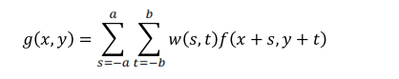 Correlation is used for various purposes, including sharpening and edge detection.

This transformation function helps to create a product array of pixels when provided with the value of

main image f (x, y) along with kernel w (s, t).

D. Laplacian

Laplacian filtering emphasizes high-frequency components, enhancing edges and details.

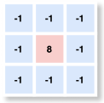The Laplacian kernel focuses mainly on the centre pixel with neighbouring pixels having less weight.

Figure 1: Laplacian Kernel

E. Sobel Mask

Sobel masks are employed for edge detection by highlighting changes in intensity.

Sobel vertical and horizontal masks are convolved with the image to compute the gradient.

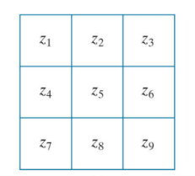For a given matrix of an image,

Figure 2: Sobel Mask

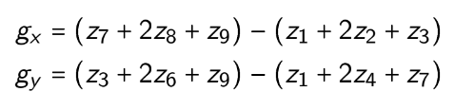Sobel Operator is:

III.RESULTS AND LESSONS LEARNT

In the testing phase, we used these image enhancement techniques on different images and acquired the

following results:

* + The Log Transform effectively brightened the dark regions of the images, enhancing visibility in shadowed areas. This was particularly useful for images with uneven lighting, revealing hidden details.
  + Histogram Equalization significantly improved the contrast of the images, making features more distinguishable. The technique successfully redistributed pixel intensities, leading to a more balanced result.
  + The Correlation technique enhanced the edges and fine details in the images. This sharpening effect contributed to a clearer depiction of object boundaries.
  + Laplacian filtering successfully sharpened the images by emphasizing high-frequency components. The resulting images had enhanced edges and a more pronounced definition of object boundaries.
  + The Sobel masks effectively highlighted edges in both horizontal and vertical directions. This edge detection technique proved valuable for identifying and emphasizing structural features in the images.

Hence, we learnt that each image enhancement technique serves a specific purpose, and the choice depends on the desired effect. So, understanding the impact of different filters on image characteristics was important for selecting the appropriate enhancement method. To achieve the optimal results with each technique, we had to change the parameters according to the image specification.

PROGRAM LISTING

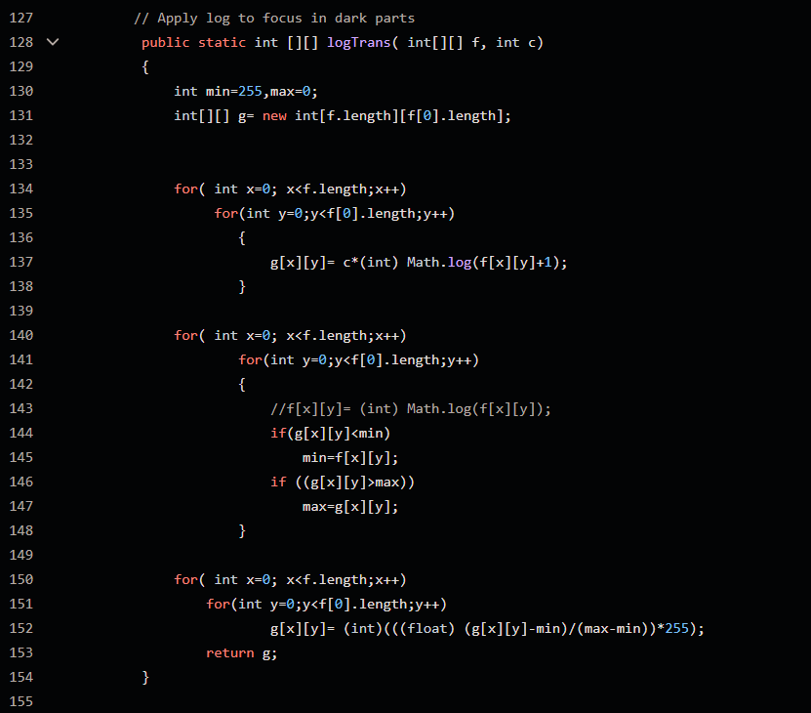//Log transformation Implementation

Figure 3: Log transformation

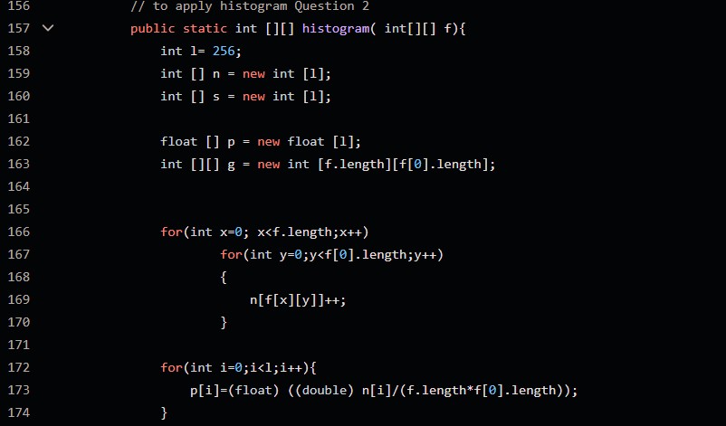//Histogram Equalization

Figure 4: Histogram pt1

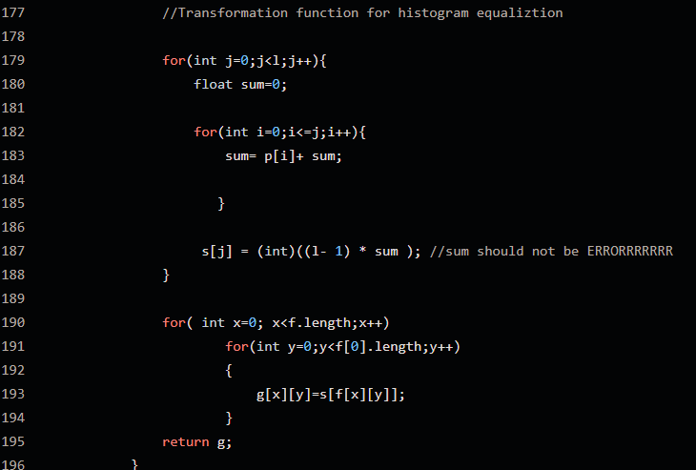

Figure 5: Histogram pt2

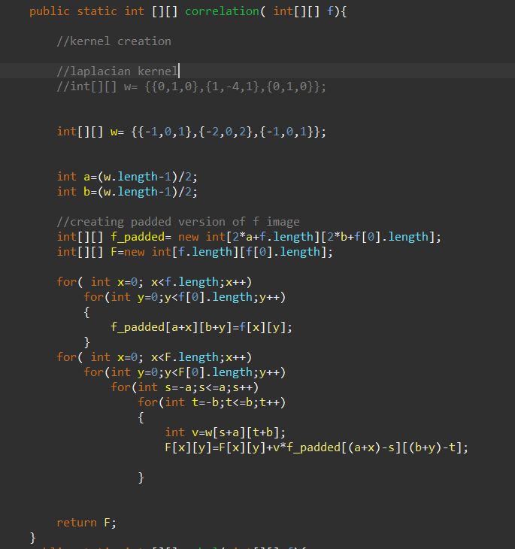//Correlation with Laplacian Kernel

Figure 6: Correlation with Laplacian Kernel

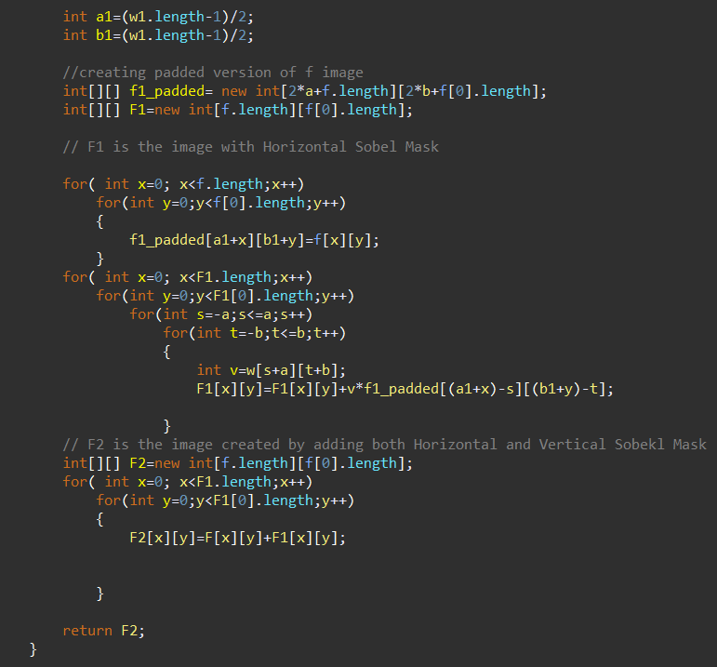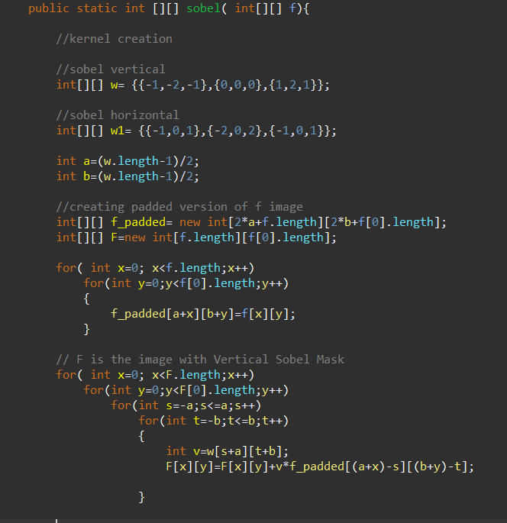//Sobel Mask

Figure 7: Sobel Mask